**MOCKITO EXERCISES HANDSON**

**Exercise 1: Mocking and Stubbing**

**Scenario:**

**You need to test a service that depends on an external API. Use Mockito to mock the**

**external API and stub its methods.**

**Steps:**

1. Create a mock object for the external API.

2. Stub the methods to return predefined values.

3. Write a test case that uses the mock object.

**Source Code:**

**MyServiceTest.java:**

import static org.junit.Assert.assertEquals;

import static org.mockito.Mockito.*;

import org.junit.jupiter.api.Test;

import org.mockito.Mockito;

public class MyServiceTest {

@Test

public void testExternalApi() {

ExternalApi mockApi = Mockito.mock(ExternalApi.class);

when(mockApi.getData()).thenReturn("Mock Data");

MyService service = new MyService(mockApi);

String result = service.fetchData();

assertEquals("Mock Data", result);

}

}

**ExternalApi.java:**

public interface ExternalApi {

public String getData();

}

**MyService.java:**

class MyService {

private ExternalApi ServiceApi;

MyService(ExternalApi api){

ServiceApi=api;

}

public String fetchData(){

return ServiceApi.getData();

}

}

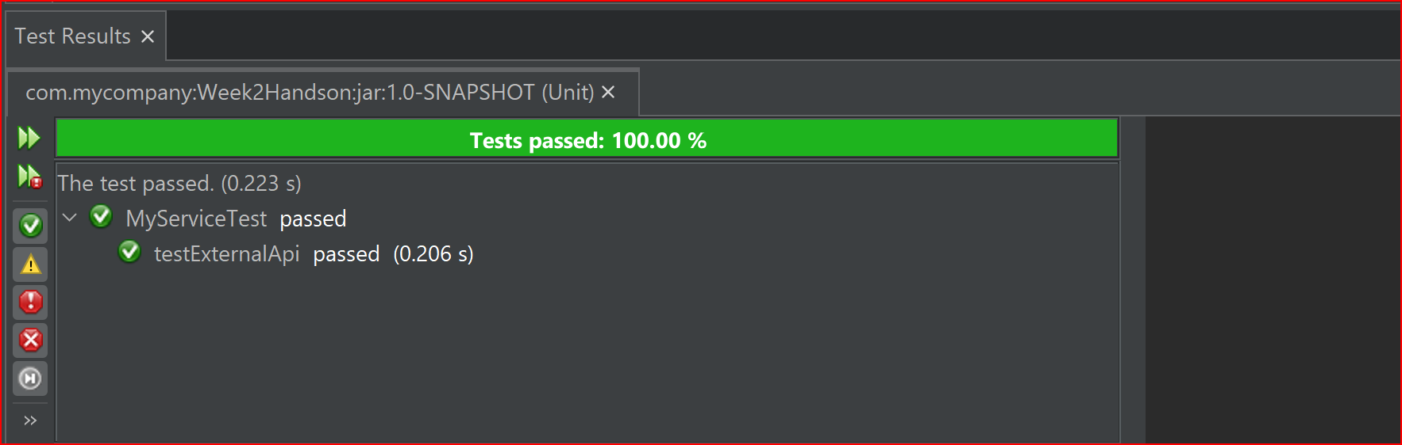**Output:**

**Exercise 2: Verifying Interactions**

**Scenario:**

**You need to ensure that a method is called with specific arguments.**

**Steps:**

1. Create a mock object.

2. Call the method with specific arguments.

3. Verify the interaction.

**Source Code:**

import static org.junit.Assert.assertEquals;

import static org.mockito.Mockito.*;

import org.junit.jupiter.api.Test;

import org.mockito.Mockito;

public class MyServiceTest {

@Test

public void testVerifyInteraction() {

ExternalApi mockApi = Mockito.mock(ExternalApi.class);

MyService service = new MyService(mockApi);

service.fetchData();

verify(mockApi).getData();

}

}

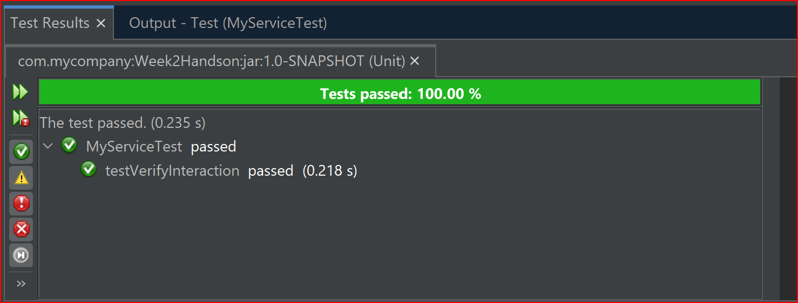**Output:**